North Versus South: What Made Them Different?

[SS05.01.02](https://home.lpsd.com/wiki/doku.php?id=ss05.01.02) Creates a Venn Diagram comparing the views of Northern and Southern Soldiers in the Civil War

[SS05.02.02](https://home.lpsd.com/wiki/doku.php?id=ss05.01.02) Sequences the major events of the Civil War

The American Civil War took place from 1861 to 1865. About 2.75 million soldiers fought during those years. About 2 million fought for the North, and the remaining 750,000 fought for the South. The Civil War is considered to be the deadliest war in American history. What would motivate all those soldiers to go fight in such a violent war? Below you will learn about soldiers who fought for the North, and soldiers who fought for the South. 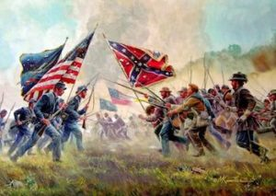

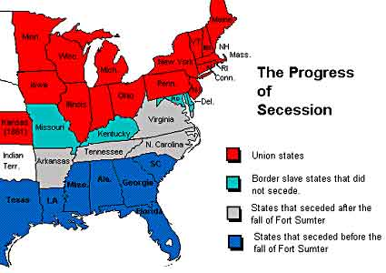

**Union (Northern) Soldiers**

Many Union soldiers were between 18-30 years old. The North was much more industrious (had more factories) than the South. This meant that the North did not have large plantations, and little need for slavery. Some men volunteered for the bounty, the cash they received to sign up. Others were looking for adventure. But the typical Union soldier was filled with intense patriotism. They felt the South was disgracing the flag. Unlike the Confederate army, which was made up of mostly Southern born white men, the Northern army was composed of native-born and immigrant men, along with soldiers of all races. In the beginning of the war, only about 80,000 men volunteered. By the end of the war, over 2 million men had volunteered. These volunteers gave the Union a huge advantage not only in numbers but in skills. There were men who could fix equipment, make weapons, repair railroads and supply routes, and build bridges and camps. Although conditions were often very rough, Union soldiers still were better fed, clothed, and sheltered than their Southern counterparts. Like the Confederate army, these volunteers were young and mostly unmarried. Like the Confederate army, they were fighting for a cause - a continuation of the cause for independence their fathers and grandfathers had fought for during the American Revolution - that of unification, to keep America strong and united, so America could maintain her independence from other countries.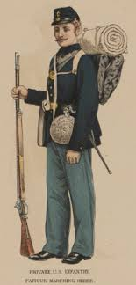

**Confederate (Southern) Soldiers**

The typical Confederate soldier had no military discipline prior to enlisting in the Confederate army. For the most part, they were young, white, Southern born men who were fighting for a cause - that cause was their independence from Northern aggression. Although slavery certainly played a part in the causes of the Civil War, as many Southern leaders were also plantation owners, it is estimated that over 90% of Confederate army volunteers owned no slaves and owned no land of size. Their fight was not to preserve slavery, but to free the South from tyranny. That's why the South did not call this war the Civil War or the War Between the States, but rather the War of Northern Aggression. What these young Rebels wanted was to establish the South, the 11 states that had succeeded from the Union, as a separate country. It was not illegal to succeed from the Union until after the war. Most volunteers were poorly fed, poorly clothed, and poorly sheltered (typically only by a blanket.) They went without pay for months at a time. They worried about their families at home. They were outnumbered. Almost one-half of all Confederate soldiers were killed, wounded, captured, or died from disease during the war. Yet, these young men continued to fight on, fired with the courage of a cause, the same cause their fathers and grandfathers had fought for during the American Revolution - that of independence.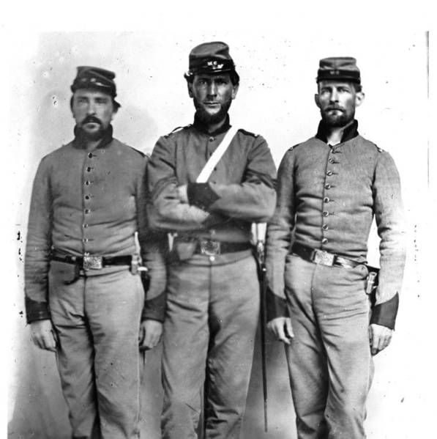

**Questions:**

1. Why did the typical Union soldier fight?
   1. Independence
   2. Intense feeling of patriotism
   3. To continue slavery
   4. To make money
2. How many men volunteered for the Union Army by the end of the war?
   1. 10,000
   2. 1 million
   3. 2 million
   4. 500,000
3. True or False: The Union soldiers were not well fed compared to the southern soldiers
   1. TRUE
   2. FALSE
4. True or False: Most soldiers fighting for the Confederacy (South) **owned** slaves
   1. TRUE
   2. FALSE
5. What did the Confederacy call this war?
   1. The War of Northern Aggression
   2. The Civil War
   3. The War of the Country
   4. The War Between the States
6. What were some reasons the southern states were fighting?
   1. To continue slavery
   2. Independence
   3. To keep the United States together
   4. A and B