Name:______________________

Date:______________________

Native American Notes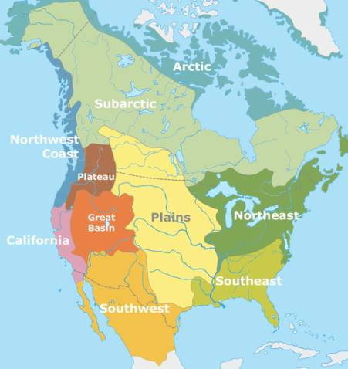

Different Regions:

* Arctic/Subarctic
* Northwest Coast/Plateau
* California
* Great Basin
* Southwest
* Great Plains
* Southeast
* Northeast

Arctic/Subarctic

* _____________________________
* _____________________________
* _____________________________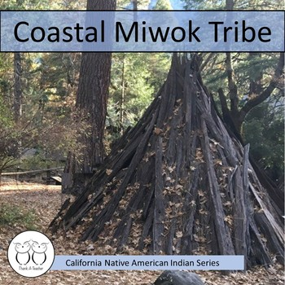

Northwest Coast/Plateau

* ____________________________
* ____________________________
* ____________________________

California

* ____________________________
* ____________________________

Great Basin

* ____________________________
* ____________________________
* ____________________________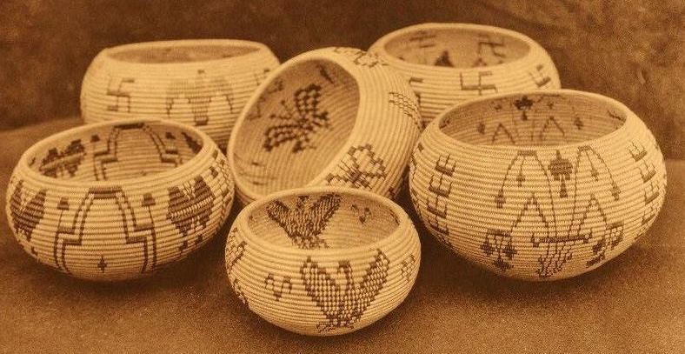

Southwest

* ____________________________
* ____________________________
* ____________________________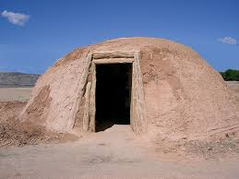

Great Plains

* ____________________________
* ____________________________
* ____________________________
* ____________________________
* ____________________________

Southeast

* ____________________________
* ____________________________
* ____________________________

Northeast

* ____________________________
* ____________________________
* ____________________________

Tools

Various Native American groups used natural resources to create tools such as:

* ___________________________
* Wood from trees
* Rocks

Shelter

Native Americans used their natural resources to create their homes. Resources include:

* _____________________________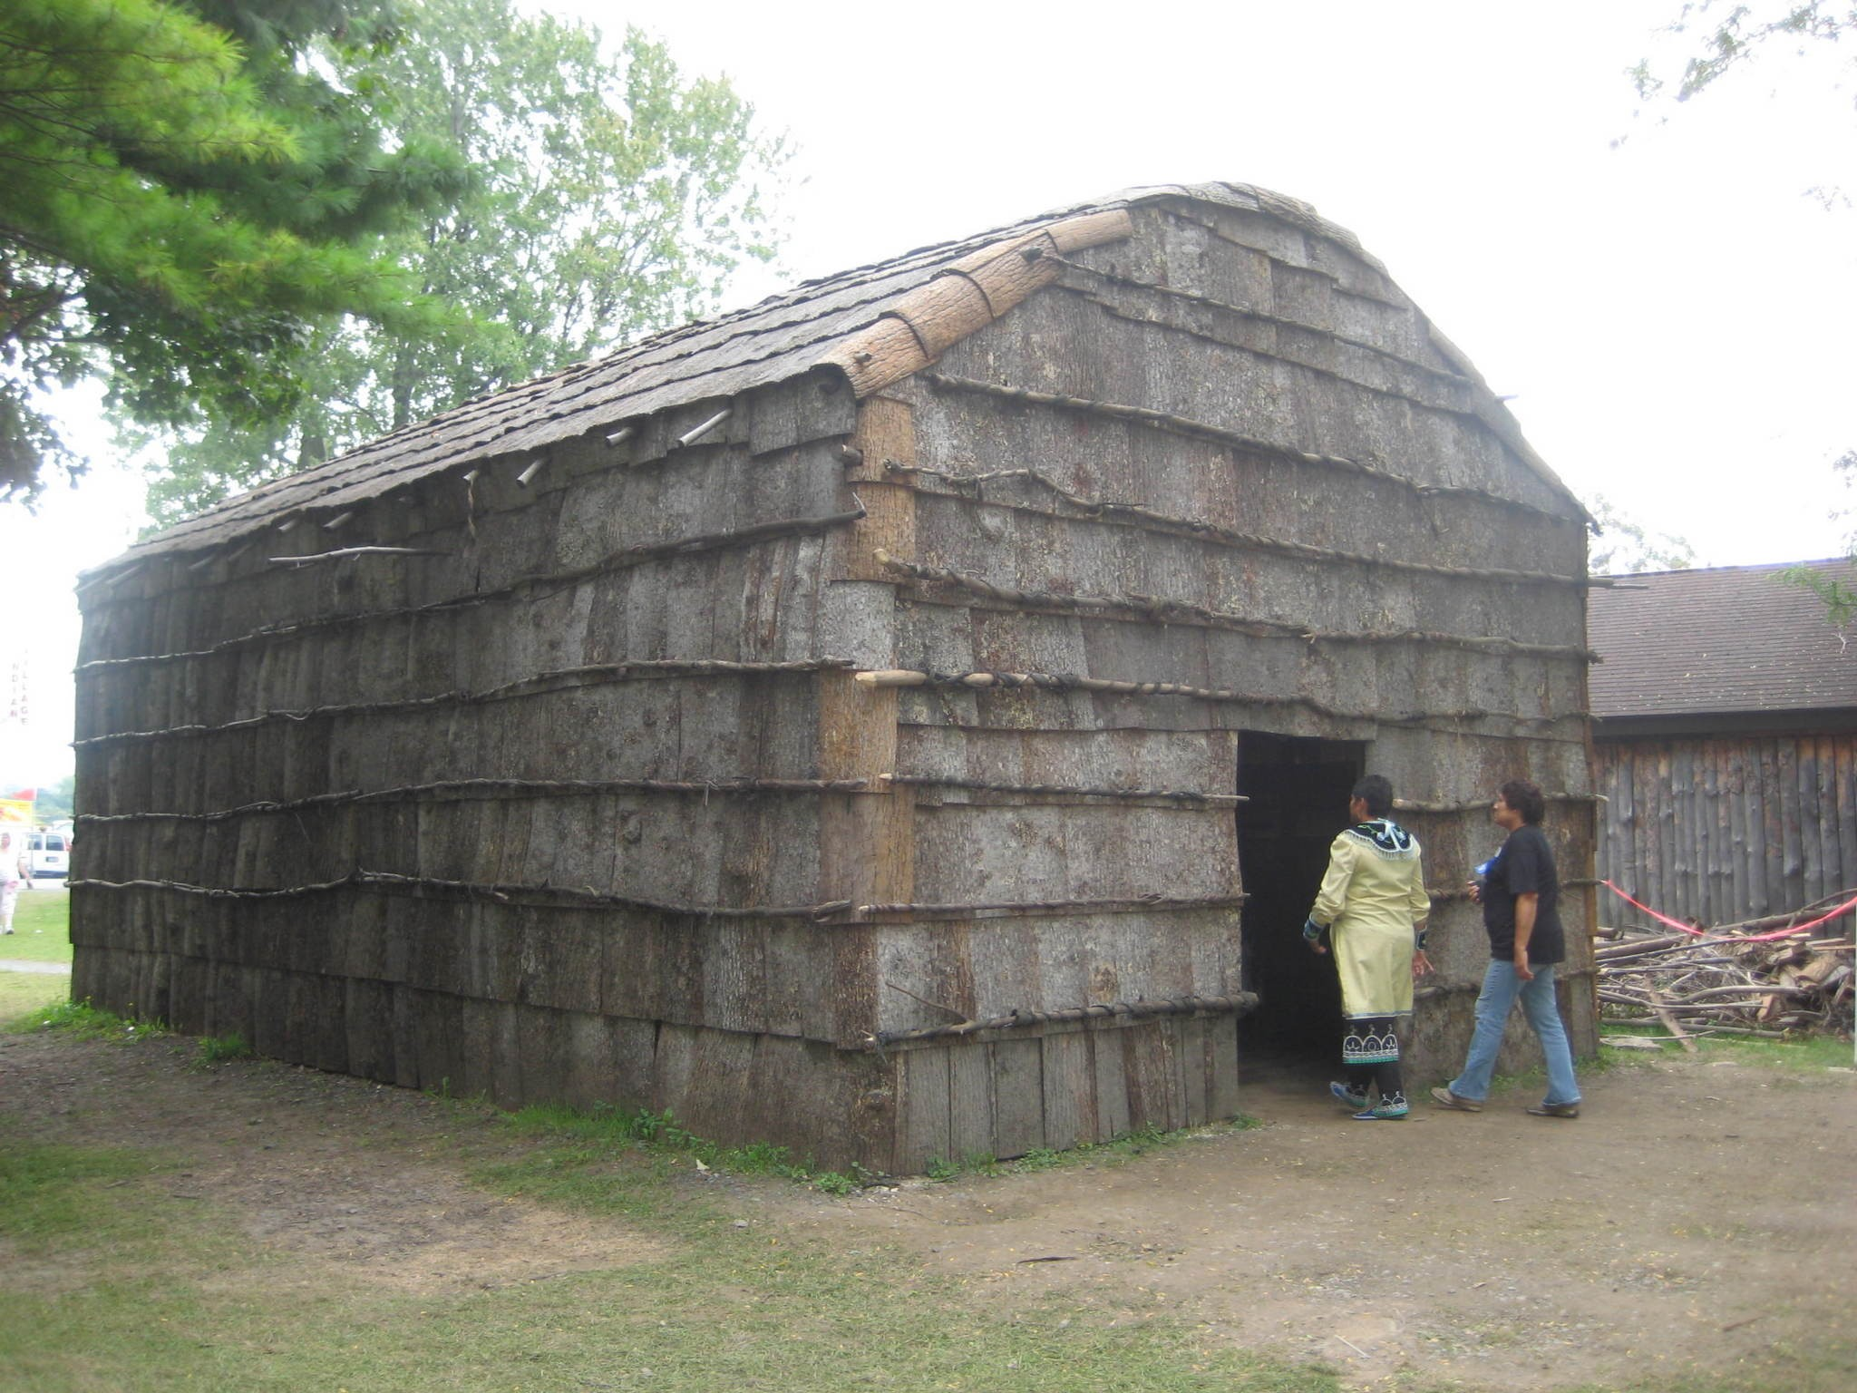
* Dirt and mud
* Clay
* ______________________________
* Snow and ice

Clothing

Different Native American Groups used their natural resources to create their clothing. These resources included:

* Animal hides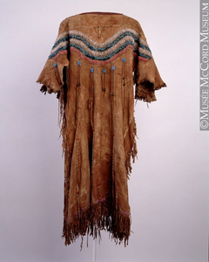
  + ___________________________
  + Caribou
  + Seal
  + ___________________________

Artwork

Native American groups all created art in their own unique ways. Some art they created included:

* __________________________
* Masks
* Totem poles
* __________________________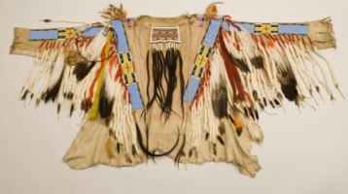
* Drawings
* Blankets
* Rugs
* __________________________
* Clay pots

Food

Different Native American groups relied on their location for food. Some of the ways they had food included:

* ___________________________
* ___________________________
* ___________________________
* ___________________________