Name:______________________________ Date:___________________

Directions: Compare the two Native American groups that you researched last class. Compare their tools, shelter, clothing, artwork, and food. If they share any similarities, then label that in the middle column. If they have their 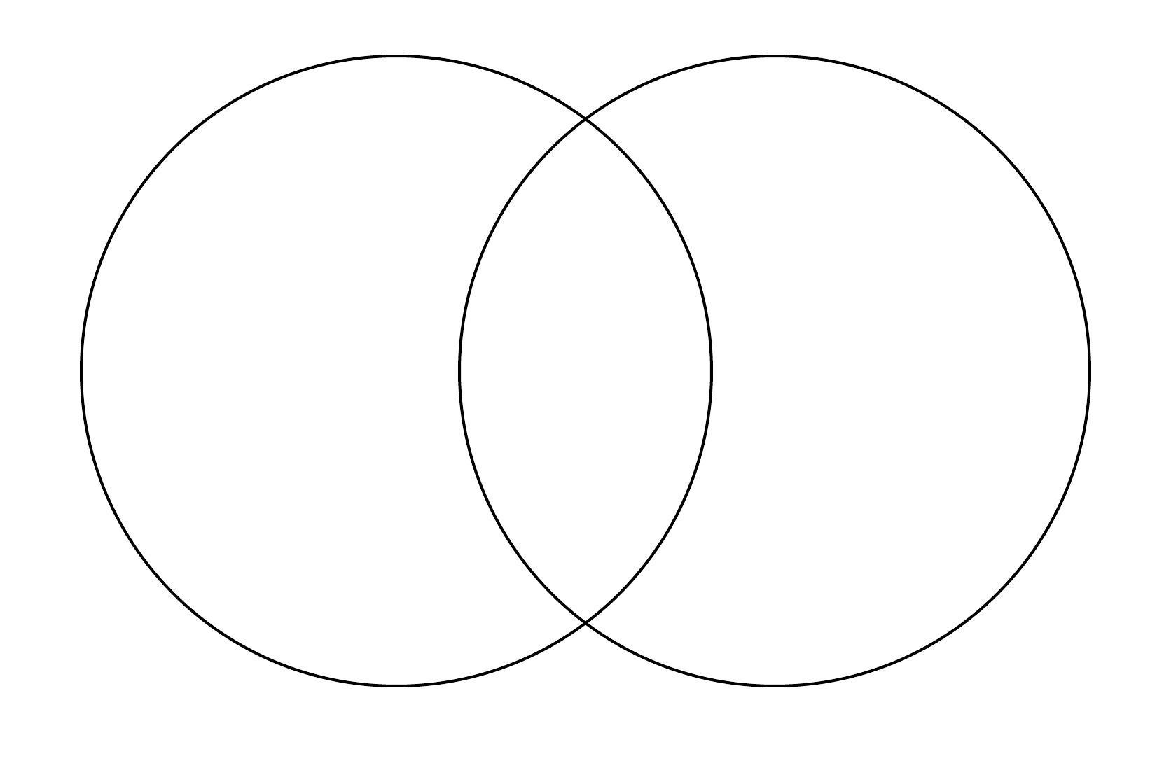

own unique qualities, write that in their individual sides. Label the Venn Diagram with the two groups you chose.