Matriarchal and Patriarchal Systems

07.08.01 Compares and contrasts matriarchal and patriarchal systems
Directions: You will be comparing and contrasting matriarchal and patriarchal systems. Use the definitions and the readings below to help you answer the questions.
Definition of patriarchy: social organization marked by the supremacy of the father in the clan or family, the legal dependence of wives and children, and the reckoning of descent and inheritance in the male line
Definition of matriarchy: a system of social organization in which descent and inheritance are traced through the female line

Examples of Patriarchal Systems:
It is believed that patriarchal societies did not come to be until roughly 12,000 years ago, with the introduction of agriculture and homesteading (settling in one location to live). The main characteristics of patriarchal societies include male dominance and power over the family, positions of power in the community and traditional roles for males and females.
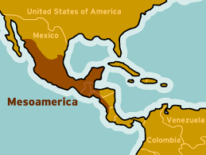
Mesoamerica: In Mesoamerica, the men were the ones who hunted and became kings. The women were to do as the man commanded, and oblige to the men’s wishes. The women cooked, cleaned, and trained their daughters to be just like them when they grew up. They mainly served two purposes: listen to the men and do as they commanded, and bear children to their husbands.

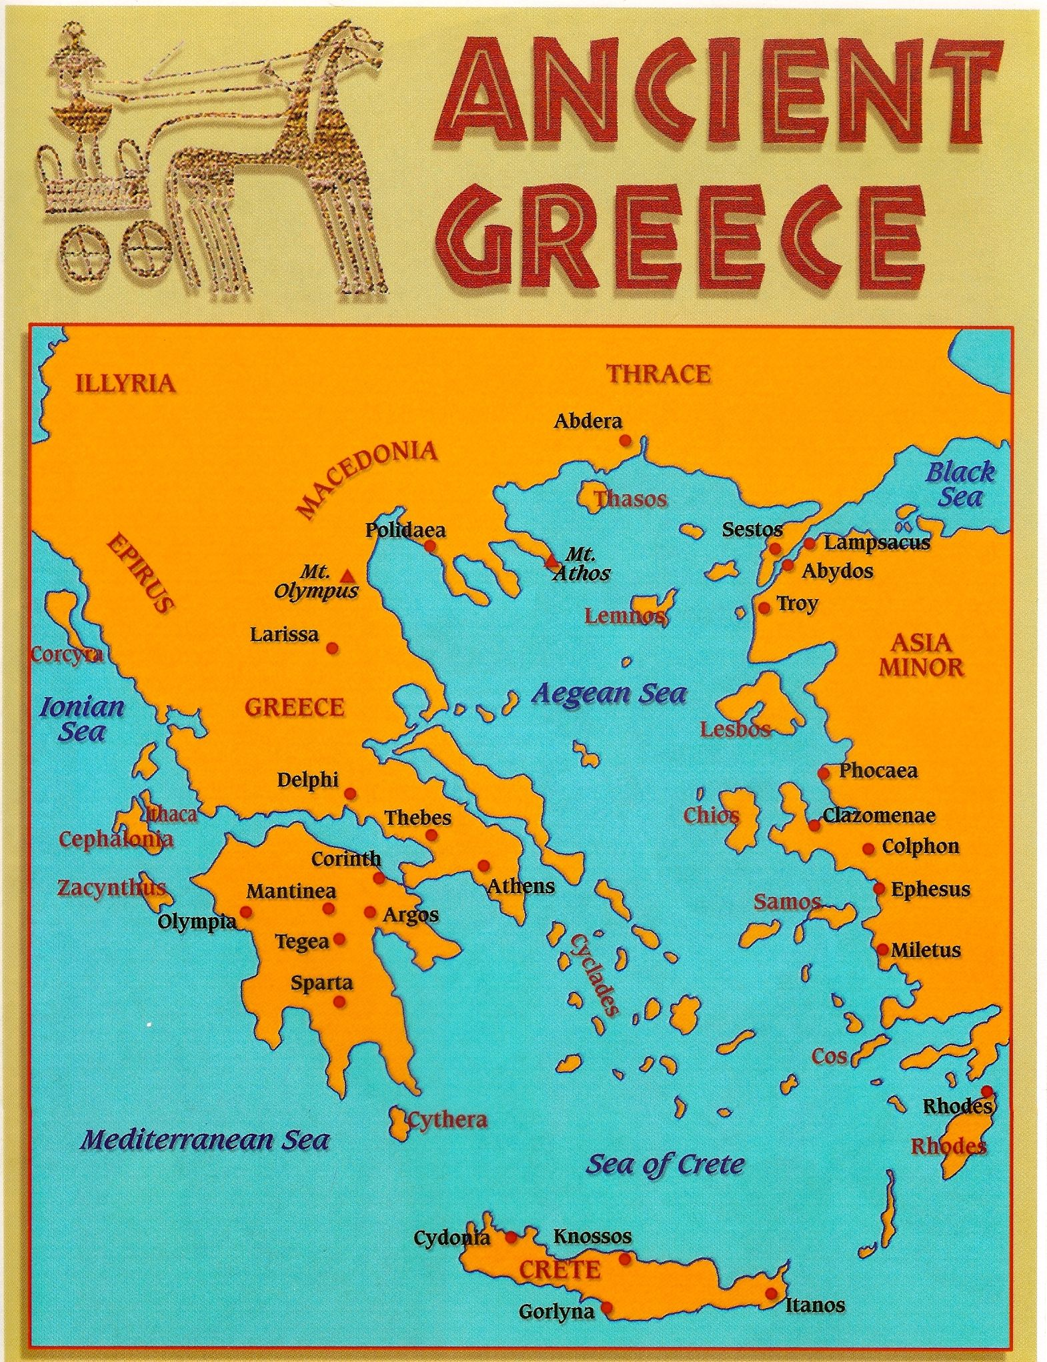
Ancient Greece: Greek women had virtually no political rights of any kind and were controlled by men at nearly every stage of their lives. The most important duties for a city-dwelling woman were to bear children--preferably male--and to run the household. Duties of a rural woman included some of the agricultural work: the harvesting of olives and fruit was their responsibility, as may have been the gathering of vegetables. Since men spent most of their time away from their houses, Greek home life was dominated by women. The wife was in charge of raising the children, spinning, weaving and sewing the family´s clothes. She supervised the daily running of the household.

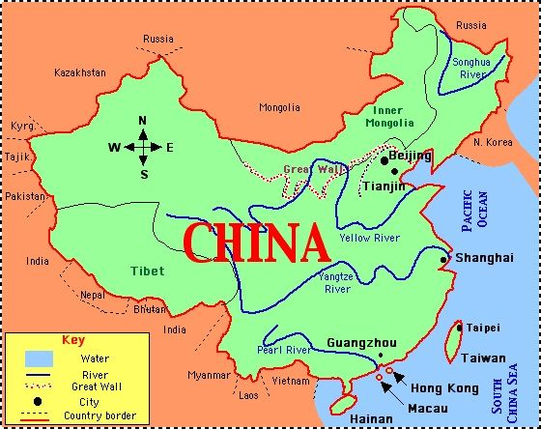
Ancient China: Women in ancient China did not enjoy the status, either social or political, afforded to men. Women were subordinate (obedient) to first their fathers, then their husbands, and finally, in the case of being left a widow, their sons in a system known as the “three followings” or sancong. Often physically ill-treated, socially segregated, and forced to compete for their husband's affections with concubines (other wives), a woman’s place was an undesirable one. Still, despite the harsh realities of living in a male-dominated society and being forever under the weight of religious and social norms which were created by men to work for men, some women did break through these barriers. Some women rose to live extraordinary lives producing great literature, scholarship, and even ruling the Chinese empire itself.

Examples of Matriarchal Systems:
Anthropologists have not discovered a truly matriarchal society, meaning that no recorded group of people have had women as the dominant figures in all aspects of their society. However, there have been societies with some matriarchal elements to them.

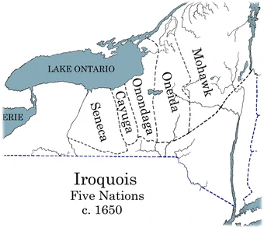
The Iroquois: Iroquois culture is matrilineal with children born into their mother’s clan. Greater respect and political power is given to female elders than any other group of the population, with a veto and impeachment system acting above chiefs (meaning women have power over who becomes a chief). As part of the matriarchy, Iroquois treaties and major changes at the Council level require consent from two-thirds of mothers. While League chiefs are men, they are elected and impeached by mothers.

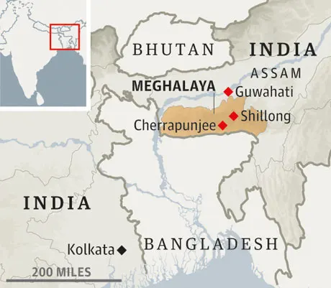
The Khāsi: The people of the Khāsi and Jaintia hills of the state of Meghālaya in India. The Khāsi have a distinctive culture. Both inheritance of property and succession to tribal office run through the female line, passing from the mother to the youngest daughter. Office and the management of property, however, are in the hands of men identified by these women and not in the hands of women themselves.

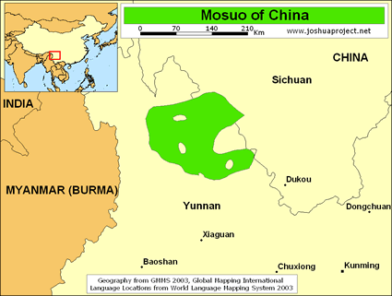
The Mosuo: In the shadow of the Himalayan mountains, at the edge of the lush, expansive Luga Lake, live the Mosuo people. Their complex social structure is said to be one of the last semi-matriarchal societies in the world, following a maternal bloodline and the practice of “walking marriage.” Women may choose and change partners as they wish, a structure that favors female independence."No one worries about commitment since any resulting children are raised in the mother's house with the help of her brothers and the rest of the community,” according to Dame Magazine. "Mosuo women carry on the family name and run the households, which are usually made up of several families, with one woman elected as the head," describes PBS Frontline World. "The head matriarchs of each village govern the region by committee."

Questions:

- In your opinion, what are some of the most important differences between a patriarchy and a matriarchy?
________________________________________________________________________________________________________________________________________________________________________________________________________________________________________________________________________
- Do you think one system is better than the other, or should both women and men be treated equally?
________________________________________________________________________________________________________________________________________________________________________________________________________________________________________________________________________

- Why do you think some societies picked one system over the other?
________________________________________________________________________________________________________________________________________________________________________________________________________________________________________________________________________

- What is an interesting fact or quality about patriarchal systems?
________________________________________________________________________________________________________________________________________________________________________________________________________________________________________________________________________

- What is an interesting fact or quality about matriarchal systems?
________________________________________________________________________________________________________________________________________________________________________________________________________________________________________________________________________

