Name:______________________ Date:______________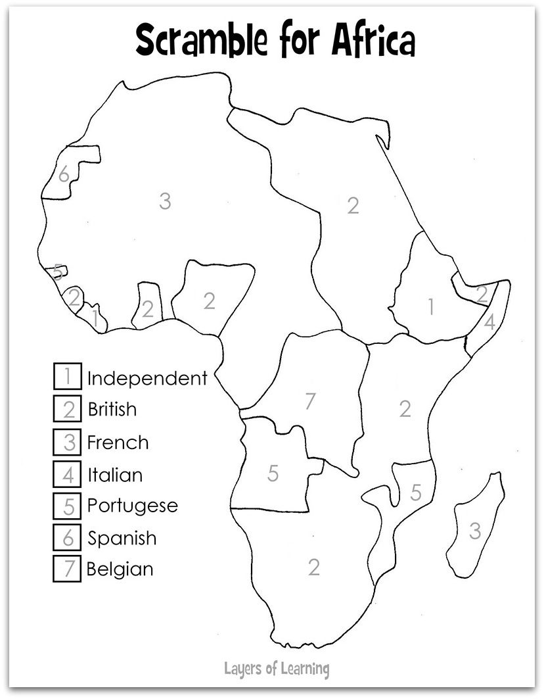

Directions: Select colors for the key and shade in the map below. The map represents the different countries that colonized Africa.