Name:_______________ Date:__________

Events Leading to the American Revolution Notes

**French and Indian War**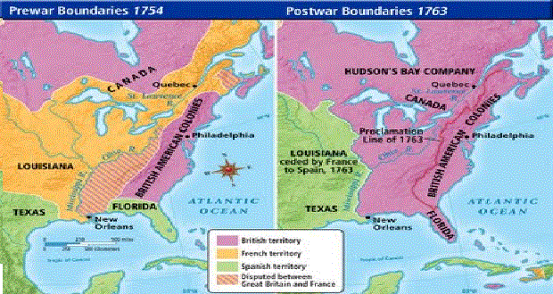

* The two sides during this war were the ___________ versus the _____________
* Both sides had Native American allies (or help), but the French had ________
* Fought over the ________ River Valley (land)
* The __________ won, and forced the French out of the New World

**Sugar Act**

* 1764 Parliament (British government) passed the Sugar Act
* Reason: to pay off the ____________ from the French and Indian War
* Taxed the sugar and molasses brought into the colonies
* Cost colonists lots of ___________ 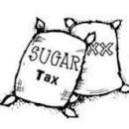

**Stamp Act**

* 1765 Parliament approved another tax
* This act put a tax on many _________ items in the colonies
* Newspapers, legal documents, playing cards, and more had a special tax
* Colonists were taxed without having a say- or without being ____________

**Quartering Acts**

* 1765 (1st act)/ 1774 (2nd act)- Colonists had to allow British soldiers into their homes
* Soldiers were able to stay at the homes- sleep and eat there
* Colonists COULD NOT turn the soldiers away!

**Boycott**

* Colonists wanted these taxes to go away, so they held ___________
* Boycott-to ___________using or buying a product
* This caused the Stamp Act to be repealed
* Repealed= ____________

**Townshend Acts**

* 1767 Parliament passed new tax laws called the Townshend Acts
* This taxed_________ , tea, paint, and paper that was brought into the colonies
* England even hired more tax collectors!
* The colonists were even more angry and ____________ more!

**Boston Massacre**

* These new tax collectors were like British soldiers all over the colonies
* The colonists didn’t like have these soldiers in their streets
* They got so angry that __________ would break out in the streets
* On_____________________, a large crowd of colonists gathered around the soldiers and threw rocks and snowballs at them.
* The soldiers fired their guns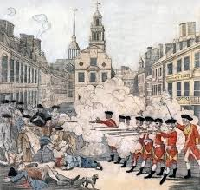
* ___________ colonists were killed on the spot and ________ others died later

**Boston Tea Party**

* 1773 Parliament passed the Tea Act
* This meant that colonist could only buy tea from England
* The ___________________decided to dress up as Mohawk Indians and sneak onto the boats
* Sons of Liberty-group of colonists who were mad about the new laws and wanted action!
* They dumped _____________of tea into the Boston Harbor

