Name:_________________ Date:__________

Road to Revolution
Review:
- Britain was in ________ because of the ___________ and _____________ War
- The ____________ were expected to pay off the debt by paying _____________
- ____________ between the colonists and the British grew as Parliament continued taxing the colonists ___________________________
- Some of the taxes included the ________________________________________________________________________________
- These tensions led to fighting and eventually a ___________
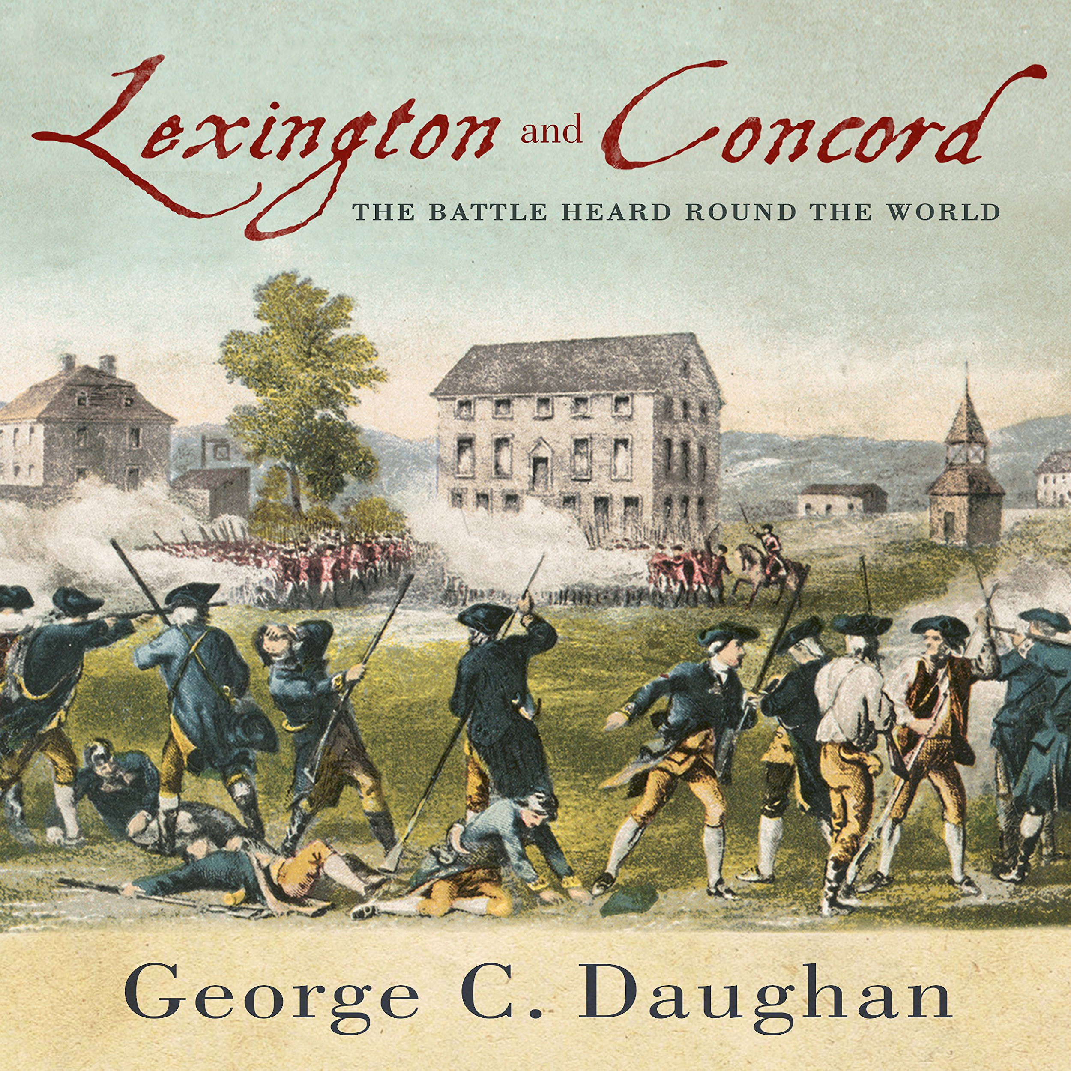
Lexington and Concord:
- Fought ___________
- First battles of the American Revolution
- The British were pushed back to Boston by the colonists
Patriots, loyalists, and… others?
- 3 different groups of colonists:
  - _______________- believed that the colonies needed to be independent from Britain
  - _______________- wanted to be ruled by Britain and were loyal to the king
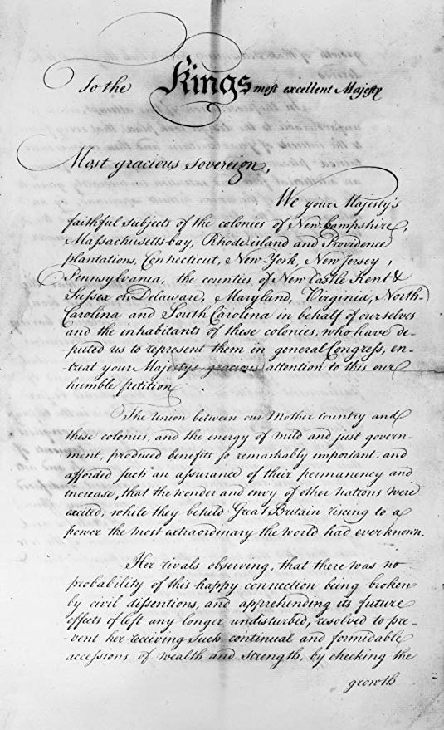
  - _______________- the last group were unsure of their feelings on independence. They were indecisive about what they wanted.
The Olive Branch Petition:
- The colonists attempted to ________a full-blown war
- In 1775 they send the Olive Branch Petition- a plea to the king asking for ___________ (as long as the colonists received representation and more rights)
- The king _____________ the petition
- This pushed the battles into a full war
Declaration of Independence:
- _______________
- The colonies officially state that they are ______________ from the British government
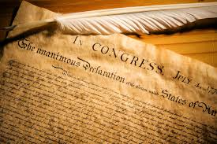
- They state that they have certain rights such as the right to life, liberty, and the pursuit of happiness

Major people on the patriot side:
- ____________________- Commander in chief of the Continental Army
- _________________ - Wanted the colonies to work together in order to win the war
- _________________- General in the Continental Army
Major people on the British side:
- _________________ - king of England and ruler of the 13 colonies
- … ________________- was originally a patriot, but betrayed the patriots by selling battle plans to the British
- ____________________ - general of the British army, surrendered to the colonists
Major Battles of the American Revolution:
- Lexington and Concord- _______
- Bunker Hill- ________
- Saratoga- _________
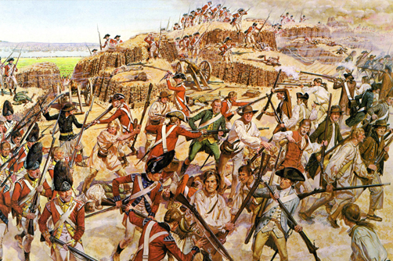
- Yorktown- ________

