Name:______________________ Date:__________________

Northern VS Southern Soldiers

**Civil War:**

* The Civil War took place from __________
* The North and the South could not agree on ________________________________________________
* The North wanted ________________________________
* 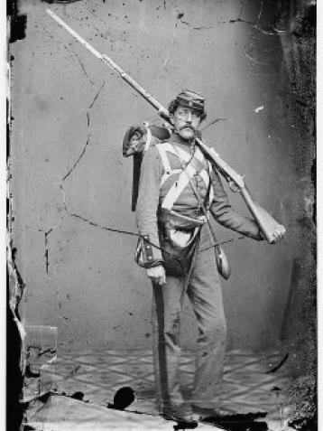The South wanted ________________________________

**The North- The Union**

* Soldiers were typically ___________________ years of age
* Many soldiers had been ___________________before the war
* Soldiers ranged in education- some went to college while others were ___________________ (couldn’t read or write)
* __________________fought for the Union- Germans, Irish, Canadians, and English
* Black men __________fight for the Union
* 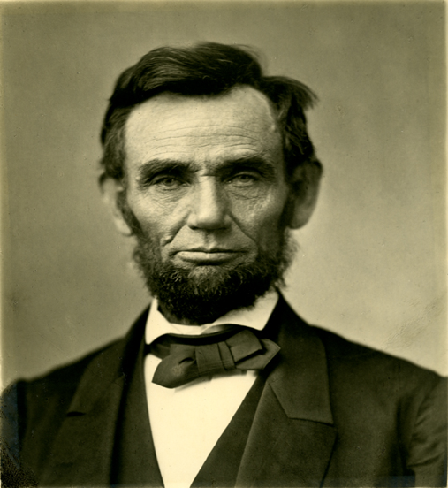Some ___________dressed up like men to fight in the army- like _________________________
* Soldiers in the Union Army __________ support slavery- they were fighting to end it
* The North was also fighting to __________________
* Union soldiers supported Abe Lincoln- the president is known as the “Great Emancipator”

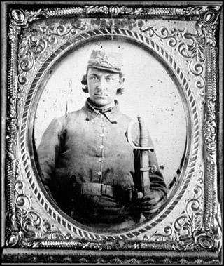**The South- The Confederacy**

* Most Confederate soldiers were years of age
* Many of the soldiers had been ________________ before the war
* Many soldiers ranged in education- from college education to being illiterate
* Foreign men helped to fight for the Confederacy-_____________,_____________, French, Poles, and Canadians
* Some black men helped the Confederacy as ________________and__________________
* The South wanted to keep slavery- ____________________________________________
* They also argued that they were fighting for _____________________
* The South did not support Lincoln because he wanted to end slavery
* ______________________ was the President of the Confederate States

