Name:_________________________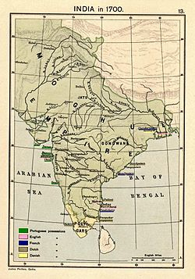

Date:_______________

Mughal Empire Notes

**When and Where:**

* The Mughal Empire lasted from ______________ AD to _____________AD
* The Mughal Empire was ___________________________in origin
* The empire ruled over most of Northern _______________

**Babur**

* Founded by ________________(ruled from 1526-1530)
* Babur was related to __________________________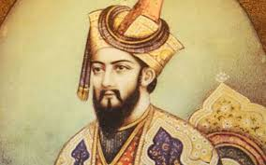
* Babur’s base was in _________________________________
* By the time he died in 1530, he ruled over all of ______________________________

**Humayun**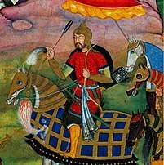

* _____________________ son
* Ruled from ___________________________
* Lost control of empire to _______________________

**Akbar**

* Grandson of _____________________
* _______________________control of empire; ruled from 1556-1605
* Considered to be the __________________Mughal emperor

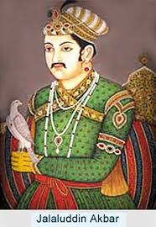

**Fall of the Mughal Empir**e

* During Muhammad Shah’s rule (1719-1748), the empire began to _________________
* After his death, the next emperor ______________________ of the empire
* The last emperor was _______________by the British after his involvement with the Indian Mutiny of 1857-1858
* This brought _________________ of the Mughal Empire

