Name:________________________ Date:____________

Rise and History of Islam

07.06.03.04

Rise of Islam- Muhammad

* Muhammad was born in ________________ in Mecca
* He was born into a noble family
* He was visited by an angel, Gabriel, who said Muhammad was a ________________________________
* Muhammad question Gabriel, but eventually believed him and began spreading ______________

Mecca Battles

* Muhammad was pushed out of Mecca in _______________- this becomes known as the Hijra
* His migration from Mecca to Medina is the start of the Islamic calendar
* Between _________________the Muslims and the Quraysh tribe battle over Mecca
* Muhammad and the Muslims eventually win back _______________

Muhammad’s Death and After

* Muhammad died in ________________ without naming a successor- so the Muslims had to decide
* After his death, the Muslims began conquering more land

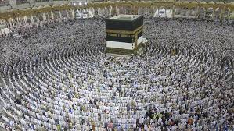

The Crusades

* The Crusades were a series of holy wars fought between European __________________ and _________________
* The Christians and Muslims fought over _____________________, otherwise known as the holy land
* The Crusades lasted from ________________ to _________________

