# **African Societies and the Beginning of the Atlantic slave Trade Part 1**

## **Overview**

* The beginning of the Atlantic slave trade in the late 1400s disrupted African societal structure as Europeans took over the West African coastline, drawing people from the center of the continent to be sold into slavery.
* New sugar and tobacco plantations in the Americas and Caribbean heightened the demand for enslaved people, ultimately forcing a total of 12.5 million Africans across the Atlantic and into slavery.

## **Early West African society**

**West Africa** stretches from modern-day Mauritania to the Democratic Republic of the Congo. It includes lush rainforests along the equator, savannas on either side of the forest, and much drier land to the north. Until about 600 CE, most Africans living in this area were hunter-gatherers. In the driest areas, herders maintained sheep, goats, cattle, or camels. In the more heavily wooded area near the equator, farmers raised yams, palm products, or plantains. 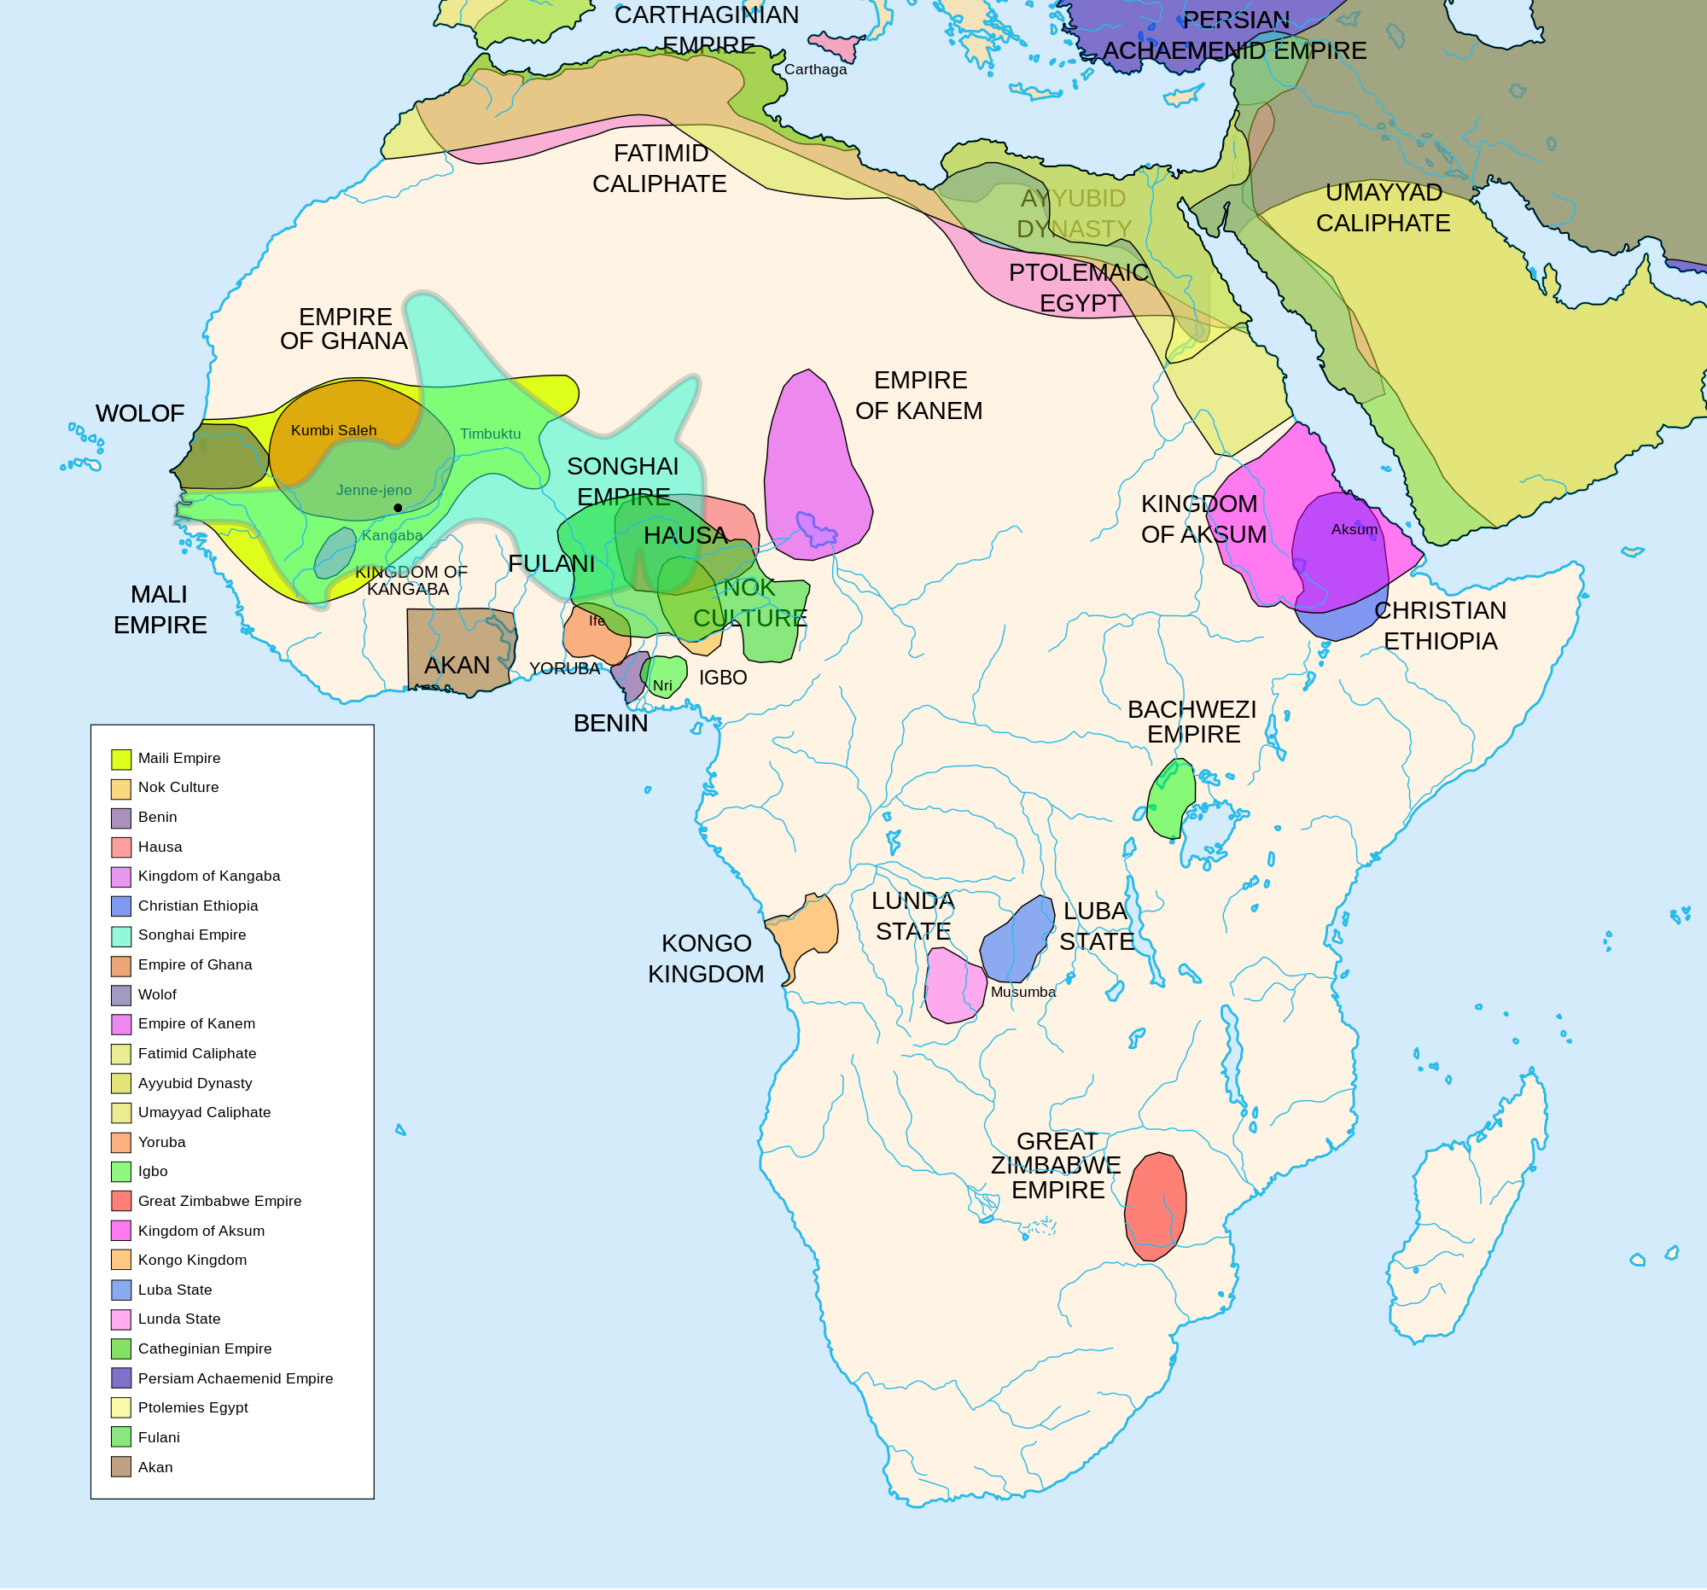

Although there were large trading centers along the rivers—the Senegal, Gambia, Niger, Volta, and Congo—most West Africans lived in small villages and identified primarily with their extended family or clan, rather than a national identity. Wives and children were a sign of wealth; men frequently practiced **polygyny**, or the custom of having more than one wife. In times of need, West Africans relied on relatives from near and far for support. Due to the many different clans in Africa, nearly 500 languages are still spoken.

African societies practiced slavery long before the Atlantic slave trade began. Famine or fear of stronger enemies might force one tribe to ask another for help and give themselves in slavery in exchange for assistance. Debt might also be worked off through some form of service or slavery. Furthermore, prisoners of war between different African societies often became enslaved.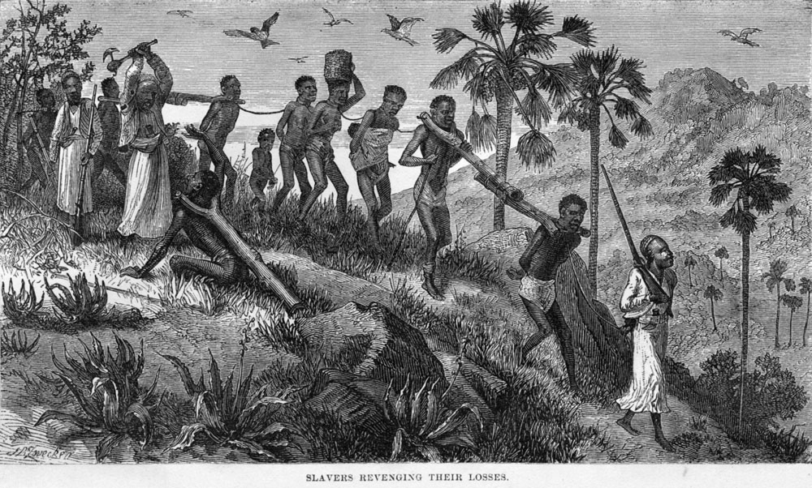

## **Religion and the African empire**

Religious movement helped shape African societal structure. Following the death of the prophet Muhammad in 632 CE, **Islam** spread quickly across North Africa, bringing not only a unifying faith but a political and legal structure as well. Only those who had converted to Islam could rule or be engaged in trade.

The first major empire to emerge in West Africa was the **Ghana Empire**. By 750, farmers of the region had become wealthy by taxing traders who traveled their area. Since Ghana’s king controlled the **gold supply**, he was able to maintain price controls and afford a strong military.

Soon, however, a new kingdom emerged. By 1200 CE, Mali replaced Ghana as the leading state in West Africa. Eventually, the court converted to Islam.. Miners then discovered huge new deposits of gold east of the Niger River. By the 14th century, the empire was so wealthy that while on a hajj, or pilgrimage to the holy city of **Mecca**, Mali’s ruler Mansa Musa gave away gold on his journey. He gave away so much gold that he caused inflation to increase. **Timbuktu**, the capital city, became a leading Islamic center for education, commerce, and the slave trade.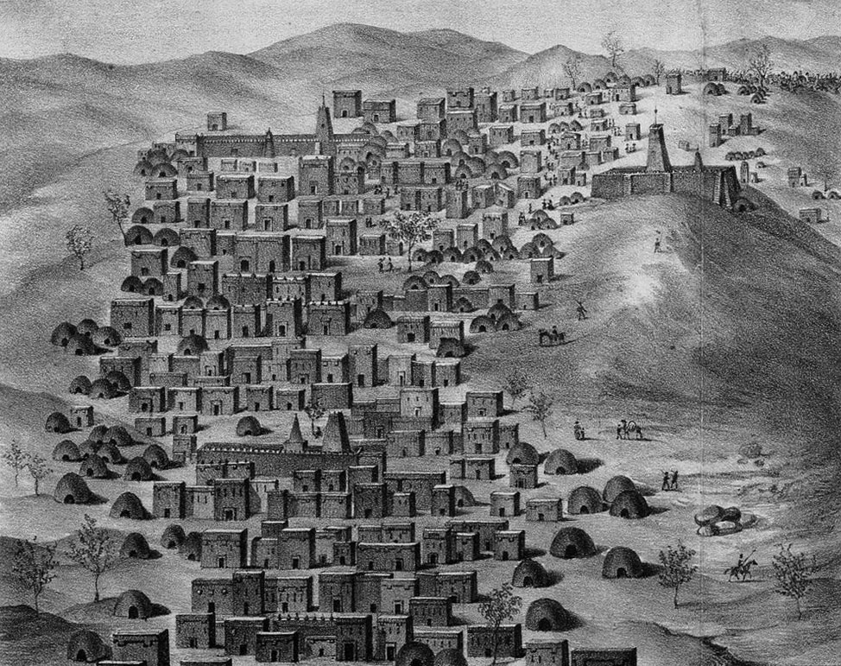

## 

## 

**Questions:**

1. How did people in Africa get their food? If they farmed, what did they grow?
2. What was family life like in Africa?
3. Was there slavery in Africa before Europeans?
4. What was slavery like in Africa **before** Europeans came to Africa?
5. What was a major religion in Africa?

# **African Societies and the Beginning of the Atlantic slave Trade Part 2**

## **The Atlantic slave trade**

The European slave trade began with Portugal’s exploration of the west coast of Africa in search of a sea trade route to the East. The East had many new resources, like spices and silk, and the Portuguese were eager to acquire these goods without the long journey by land from Europe to Asia.

In 1482, Portuguese traders built **Elmina Castle** in present-day Ghana, on the west coast of Africa. This was a fort for trade, and also protection. Although the Portuguese originally used the fort for trading gold, by the 16th century they had shifted their focus to trading enslaved people, as the demand for slave labor ballooned in the New World.

The dungeon of the fort turned into a holding pen for Africans. On the upper floors, Portuguese traders ate, slept, and prayed. Enslaved people lived in the dungeon for weeks or months until ships arrived to transport them to Europe or the Americas. For them, the dungeon of Elmina was their last sight of their home continent.

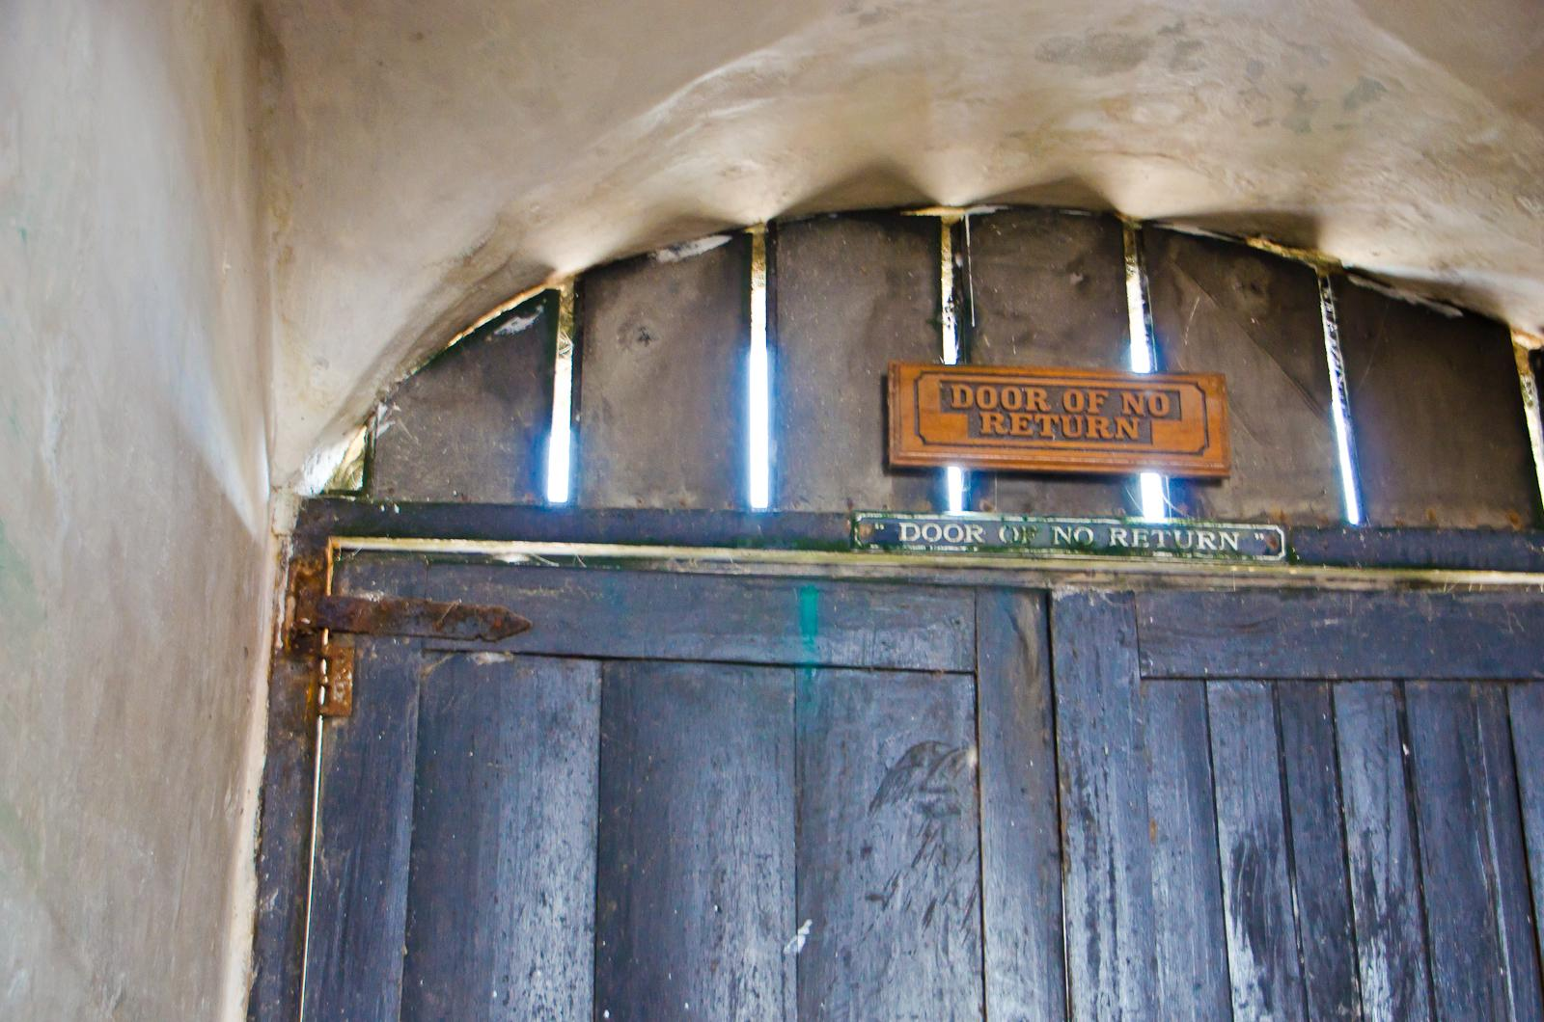

The door of no return at Elmina Castle.

By 1444, the Portuguese brought enslaved people from Africa to work on the sugar plantations of the Madeira Islands, off the coast of modern Morocco. The slave trade then expanded across the Atlantic as European colonies demanded an ever-increasing number of workers for the extensive plantations (farms) growing the labor-intensive crops of tobacco, sugar, and eventually rice and cotton.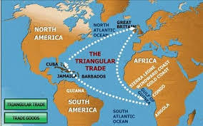

Soon, the Spanish, Dutch, and English all followed the Portuguese in transporting enslaved people across the Atlantic. The Trans-Atlantic Slave Trade Database estimates that 12.5 million Africans were sent through the **Middle Passage**—the path across the Atlantic—to work in the Americas. Many Africans died on their way to the Americas, and those who did arrive often faced conditions worse than the slave ships.

**Questions:**

1. Why did Europeans originally go to Africa?
2. What did they shift their focus to after spending some time in Africa?
3. Where did Africans stay before they were sent to the Americas as slaves?
4. What types of plantations did slaves work on? (They list several crops that required more labor)
5. What was the Middle Passage? How many Africans were sent on the Middle Passage?