NAME: ________________________________
SS 11.2.5 Uses census data from the last 50 years to describe population changes in India and China
WebQuest: Population in China & India

Website: www.china-profile.com/data/fig_p19a_m.htm
Assignment: Use the graph, annotations, and article to complete the exercises below.
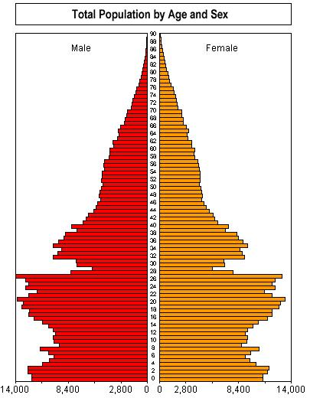
- What year was this data collected? _________
- Which gender is usually greater in number? ________
- On the graph, circle the “baby boom”.
- On the graph, circle the “Great Leap Forward”.
- What caused the severe “cut” in births during the Great Leap Forward?

- What are some other causes of areas of low population in the graph?

- In which age group are women more numerous than men? ________________________
- What can you infer (figure out that isn’t said) about the “Chinese family planning program”?

- On the graph, circle the areas (age groups) affected by the “Chinese family planning program”.
- What is meant by ‘the “echo effect” of the baby boom’?

Backside →
Website: Google.com Search: China growing old before rich (theglobeandmail.com…)
Assignment: Read the first six paragraphs of the article and analyze the ‘Infographic’ data.

- What was Mr. Zhang concern for the future? ________________________________________________
- What was the population of China in 2010? ________________________________________________
- Why did the Chinese government introduce the one-child policy?

- Why is it a problem for China to have such a large group of elderly citizens?

Assignment: Click and analyze the ‘Infographic’ data to complete the exercises below.

- Is China’s population becoming more urban (city-living) or rural (country-living)? _____________________
- Which portion of China has the highest concentration of large cities? ______________________________
- How many more males are there in China than females? ____________________________________
- Predict two effects that the difference in the number of males and females will have on China.
  - _________________________________________________________________________________
  - _________________________________________________________________________________

Website: Google.com Search: India launches biometric census (news.bbc.co.uk…)
Assignment:

- What was India’s population in 2003? ______________________________
- According to the data, how long are Indians expected to live? __________________
- According to the total fertility rate, the average Indian woman has how many children? ____________
- What happened to India’s population between 1960 and 2000? ______________________________
- Use the Population Growth line graph to describe the trend that you see in India’s population.

- Make a comparison between China’s and India’s Population Pyramids.

