NAME: ________________________________
SS 11.2.4 Analyzes modern genocides (i.e. Rwanda, Darfur, Serbia, Congo)

Web quest: Modern Genocide

Website: www.ushmm.org
Assignment: Hover over “Genocide” in the header at the top and click “What is Genocide?”
Read “An Evolving International Framework” and complete the exercises.

- What historical events spurred the creation of the word “Genocide”? ________________________
- List and explain in simple terms each of the four types of groupings considered by the UN Convention.
  - N_________________ = a person’s ________________________________________________
  - E_________________ = a person’s ________________________________________________
  - R_________________ = a person’s ________________________________________________
  - R_________________ = a person’s ________________________________________________
- Refer to the “acts of genocide” (list a-e) to respond to the following questions.
  - Should rape by one group against another be considered an act of genocide? Why or why not?

  - Should it be considered genocide if an overpopulated country taxes citizens for have more than two children? Why or Why not?

Assignment: Click “Who is at Risk?” in the header at the top of the page.
Read the Introduction paragraphs to each of the six modern genocides.

- Which two African nations pose the most serious threat of genocide?
____________________________________ __ _________________________________________
- Which country experienced the greatest loss of life due to genocide? ______________________________
- Which country’s genocide took place in Europe? ______________________________
- Which two countries experienced genocide between the same ethnic groups?
____________________________________ __ _________________________________________
Backside →
Assignment: Click “DR Congo” and read the article entitled “Overview”

- List the five reasons that make DR Congo (formerly Zaire) a threat of genocide.
  - _________________________________________________________________________________
  - _________________________________________________________________________________
  - _________________________________________________________________________________
  - _________________________________________________________________________________
  - _________________________________________________________________________________
- What caused ‘Zaire’s’ first war in 1996? ______________________________________________________
- What was the primary cause of the death of 5.4 million since 1998? _______________________________
- What landmark event took place in 2006? ________________________________________________
- Create a list of problems that DR Congo continued to struggle with after their first elections.

Assignment: Click “Acts of Violence” and read the article entitled “Acts of Violence”

- List one difficult fact that stood out to you personally.

- Why did you choose the fact above and how did it affect you?

- If you had infinite resources available, what three measures would you take to bring relief to the DRC?

Assignment: Click “Who is at Risk?” in the header and then click “Sudan”
Read the article entitled “Overview: Sudan”

- How long has Sudan’s second civil war lasted? _________________________________________
- What factors divide the people of Sudan?
_________________________________________ _________________________________________
_________________________________________ _________________________________________
- What region of Sudan experienced intense violence that the museum called genocide? _______________
- List 5 genocidal actions that the Sudanese government has committed against its citizens?
  - _________________________________________________________________________________
  - _________________________________________________________________________________
  - _________________________________________________________________________________
  - _________________________________________________________________________________
  - _________________________________________________________________________________

Assignment: Click “Responses” and scroll down to “To genocide and conflict in Darfur”
Read the article section entitled “To genocide and conflict in Darfur”

- What caused a “wide array of measures” to be sent to Darfur?

- What country was first to declare the violence in Darfur “genocide”? ______________________________
- What caused the majority of deaths in Darfur? _______________________________________________
- Why do you believe that people began to attack humanitarian aid workers?

- How effective have AU and UN forces been at changing the situation in Darfur?

- Based on what you know now, should the U.S. send peacekeeping troops to Darfur? Why or Why not?

Assignment: Search for and watch the video “Smallest Witnesses”. Just watch; no exercises to do.
Backside →
Assignment: Click “Who is at Risk?” in the header and then click “Burundi”
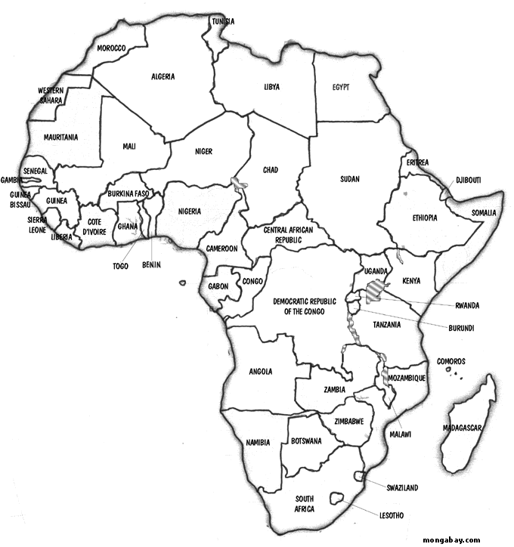
Click “Acts of Violence” and read the article entitled “Acts of Violence”

- Color Burundi, Rwanda, DR Congo, and Sudan on the
map of Africa to the right.

- What sparked the mass killings in Burundi?

- Which group killed more people, the Hutus or the Tutsis?

- What is meant by ‘internal displacement’ at the end of the article?

Assignment: Click “Gallery” in the header and then click “more” under “Eyewitness Testimony”
Choose three videos to watch and summarize each below (no holocaust videos please)

- Eyewitness #1: ______________________________ Genocide location:____________________________
______________________________________________________________________________________________________________________________________________________________________________
- Eyewitness #2: ______________________________ Genocide location:____________________________
______________________________________________________________________________________________________________________________________________________________________________
- Eyewitness #3: ______________________________ Genocide location:____________________________
______________________________________________________________________________________________________________________________________________________________________________
- “Share” online the most influential video that you watched using the “share” button below the video description. Ask your teacher which sharing method would be best for you to use.

